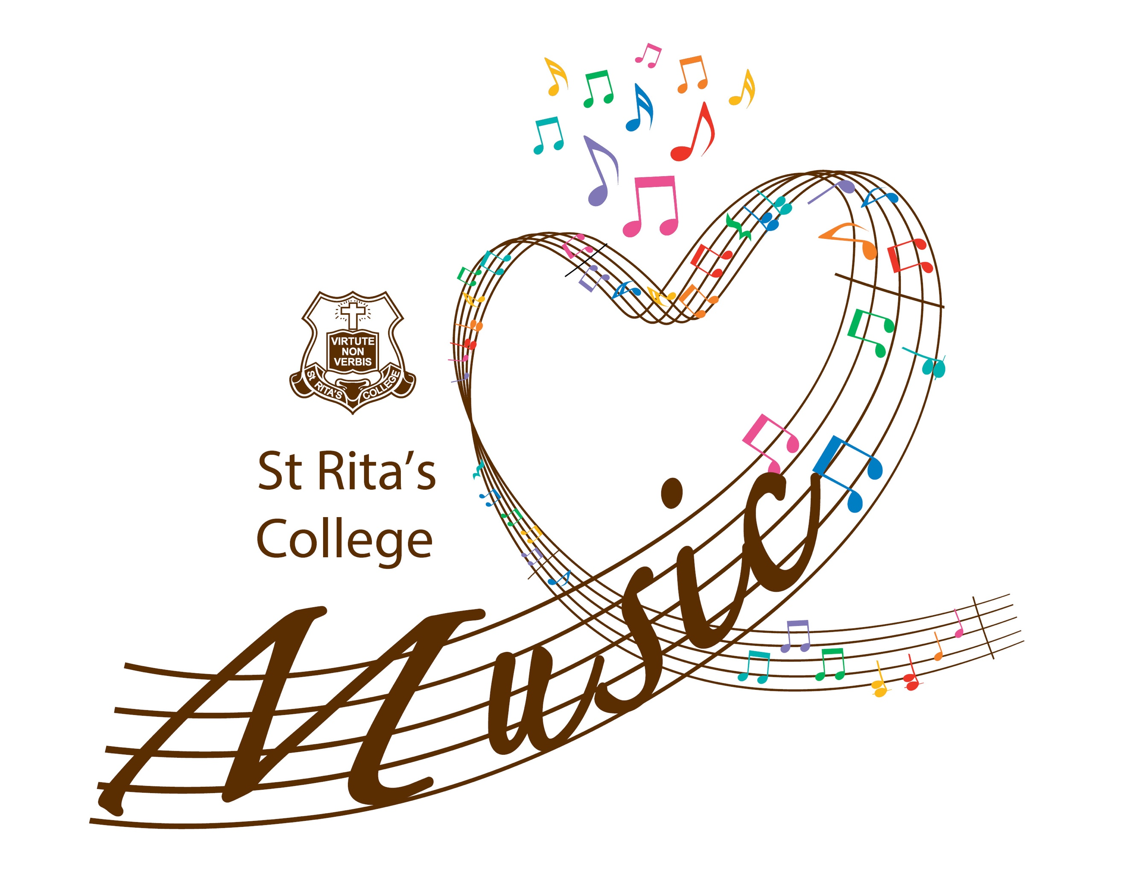
St Rita’s College 2021 BIGs Program
Available for current Year 5 St Agatha’s students
St Rita’s College Music Department invites current Year 5 students at St Agatha’s to join our BIGs program for 2021. Beginner Instrumental Groups (BIGs) is a program that caters for students who have not previously had any instruction on a woodwind, brass or orchestral string instrument and would like to commence learning one of these instruments. Students will have the opportunity to learn an instrument through group instruction and will receive music lessons and instrument hire during Terms 1 – 3 in 2021.
Lesson times for BIGs students will take place each Tuesday morning from 7:30-8:30am in the St Rita’s College Music Centre during Terms 1 - 3. The cost of the program will be $150 and will be invoiced through College accounts at the start of the year. An instrument and other resources will be supplied by St Rita’s College.
Instrument Matching and Fittings
Learning to play an instrument can be challenging however with the appropriate instrument and instruction, all students can achieve success. Interested students will be required to complete the online Instrument Matching tool and attend an Instrument Fitting session. The Matching Tool can be completed at any time but must be completed by the student. After completing the Matching Tool, be sure to book in for an instrument fitting session for Monday 30 November or Tuesday 1 December.
Available instruments include:
Woodwind - Clarinet, Saxophone
Brass - Trumpet, Trombone, Euphonium
Percussion
Strings - Viola, Cello, Double Bass
How to Enrol for BIGs
If you are interested in enrolling in the program please complete the steps using the links below:
1. Watch the instrument demonstrations on our BIGs webpage.
2. Students complete the online instrument matching tool.
3. Book an instrument fitting for Monday 30 November or Tuesday 1 December
4. After the instrument fittings have been completed and upon receiving an offer in the program, fill in the Placement Acceptance Confirmation.
5. Sit back and enjoy the holidays.
6. Come to the first lesson on Tuesday 2 February from 7:30-8:30am. Students just need to arrive with themselves at the St Rita’s College Music Centre on the top floor of the Trinity building. All instruments and materials will be given out at this first lesson.

We look forward to supporting students in taking up this opportunity. Please contact the St Rita’s College Music department (music@stritas.qld.edu.au) for more information.

